OUTDATED INFO CURRENTLY ON CYFD WEBSITE:
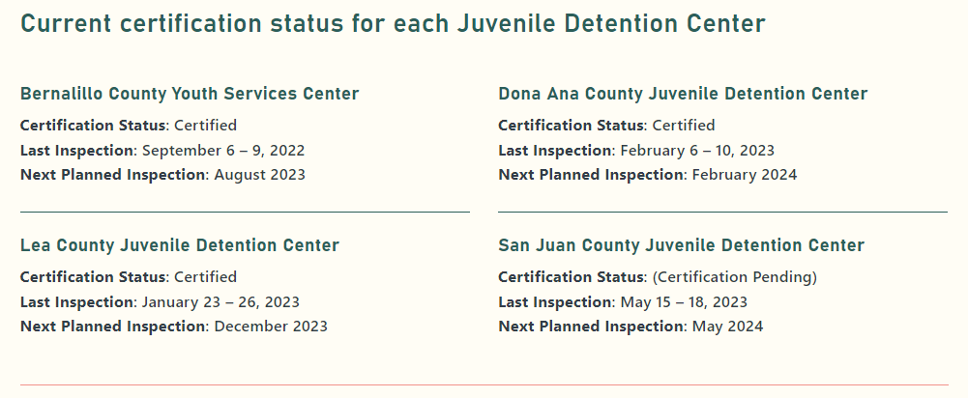

UPDATED INFO FOR CYFD WEBSITE:
Current certification status for each Juvenile Detention Center
Bernalillo County Youth Services Center  Certification Status: Provisionally Certified  Last Inspection: August 22 – 25, 2023  Next Planned Inspection: January and August 2024 | Dona Ana County Juvenile Detention Center  Certification Status: Certified  Last Inspection: February 6 – 10, 2023  Next Planned Inspection: February 2024
Lea County Juvenile Detention Center  Certification Status: Certification Pending  Last Inspection: December 4 – 8, 2023  Next Planned Inspection: December 2024 | San Juan County Juvenile Detention Center  Certification Status: Certified  Last Inspection: May 15 – 18, 2023  Next Planned Inspection: May 2024

